IR Codes for Adafruit Mini Remote Control with TSOP38238 decoder

Wire decode:

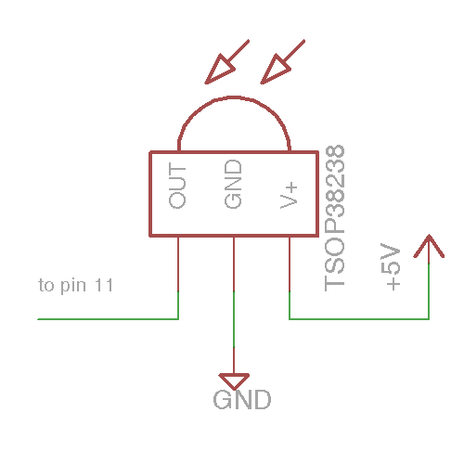

But also include a RED LED in series with 220 Ohms between 5V and OUT… when OUT drops low, the LED turns on. It flickers when it receives IR info. Great diagnostic.

#include <IRLib.h>

//Create a receiver object to listen on pin 11

IRrecv My_Receiver(11);

//Create a decoder object

IRdecode My_Decoder;

//32 bit value of the button pressed on IR remote

unsigned long reading = 0;

void setup()

{

Serial.begin(9600);

My_Receiver.enableIRIn(); // Start the receiver

}

void loop() {

//Continuously look for results. When you have them pass them to the decoder

if (My_Receiver.GetResults(&My_Decoder)) {

My_Decoder.decode(); //Decode the data

if(My_Decoder.value != 0xFFFFFFFF)

{

reading = My_Decoder.value;

}

Serial.println(reading, HEX);

//My_Decoder.DumpResults(); //Show the results on serial monitor

My_Receiver.resume(); //Restart the receiver

}

}

|  |  |
| --- | --- |
| Button | Reading (HEX) |
| Vol - | FD00FF |
| Play/Pause | FD807F |
| Vol + | FD40BF |
| Setup | FD20DF |
| Up Arrow | FDA05F |
| Stop/Mode | FD609F |
| Left Arrow | FD10EF |
| Enter/Save | FD906F |
| Right Arrow | FD50AF |
| 0 10+ | FD30CF |
| Down Arrow | FDB04F |
| Undo | FD708F |
| 1 | FD08F7 |
| 2 | FD8877 |
| 3 | FD48B7 |
| 4 | FD28D7 |
| 5 | FDA857 |
| 6 | FD6897 |
| 7 | FD18E7 |
| 8 | FD9867 |
| 9 | FD58A7 |

Sometimes get spurious readings of 0